Drawing grid in Inkscape in millimeter
http://graphicdesign.stackexchange.com/questions/21611/drawing-grid-in-inkscape-in-millimeter

If I try to draw a grid in Inkscape, there are two different options:
- Extra -> Render -> Grid
- Extra -> Render -> Kartesian Grid
But both of them use pixel-metric(?).
Is it possible to use other metrics (e.g. millimeter).
As a workaround, I converted pixel->millimeter, but it didn't work. There is always an odd scale factor in the conversion :-(.
Do you have any solution?

RESPUESTA 1

Sadly, menu Extensions -> Render -> Grids > Grid... does only take pixels as the measurement.
So I am pretty sure conversion is the way to do it. I find the easiest, most accurate way to do conversion calculations for Inkscape is to do it in Inkscape.
Use the rectangle tool to draw a rectangle on the canvas, then in the tools control bar for the rectangle tool, change the units to mm, and set the rectangle to the value you need (in the picture below, I set it to 5 mm square).
Now, simply change the units back to px, and the width and height should have been converted to the pixel value:

RESPUESTA 2

I prefer to use Inkscape's built-in document grid option.
Press Shift+Ctrl+D or navigate to File→Document Properties→Grids
Select Rectangular Grid and hit the New button.
You can then edit the properties (and units) of the created grid in the same dialog.
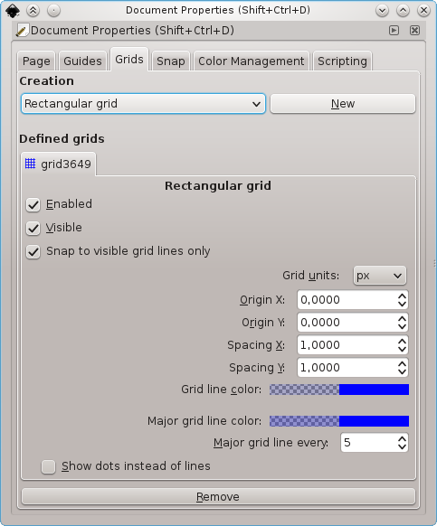

RESPUESTA 3

I don't know if the answer is to specific, but since their is no general solution to this problem, I cloned Inkscape and patched the grid functionality.
I'll try to improve my patch, so it will be maybe in a release version one day (so please don't down-vote instantly). Until then, one has to clone my repository and build it.
My solution is as follows:
Extra -> Render -> Grids -> Grid -> Divide Selection by Spacing FA
By using this option, one can use the factor given in "Horizontal/Vertical Spacing" as subdivision factor for the selection.
- Parameterize the selection in pt/cm/m/in/.. (or whatever)

- 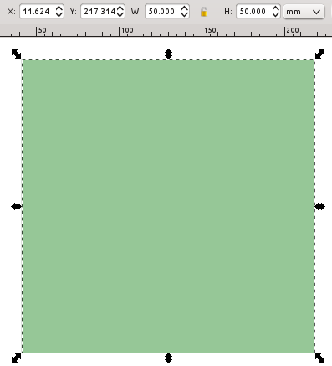

- Create a grid by Extra -> Render -> Grids -> Grid
- Set a tip at Divide Selection by Spacing FA
- Select how many subdivisions of you selection you want to have

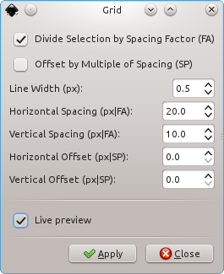

- Et voilà, a grid with 50mm/10=5mm vertical spacing and 50mm/20=2.5mm horizontal spacing
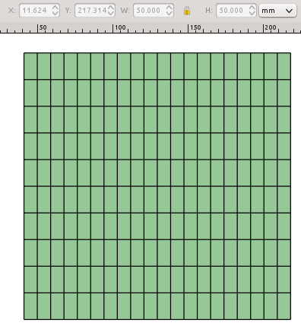
- It is also possible, to have an offset in the scale of a subdivision 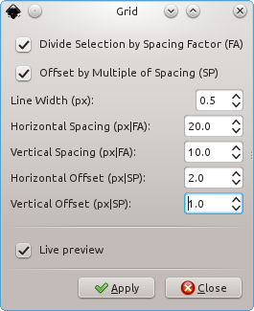
- The grid is now shifted in x and y direction respectively 